Ajinomoto Philippines – KPI Reports, Dashboards & IT Integration Requirements
Workshop Session 4 · Oct 29, 2026 · @Srini

1. Workshop context and scope
Session 4 reviewed every procurement KPI report APC produces today. All of them are built by hand in Excel from SAP extracts and manual logs. The aim is to have the new platform generate the operational ones automatically and feed executive KPIs such as DIO and DPO.
Item | Detail
Client | Ajinomoto Philippines Corporation (APC), Project Beacon
Session | Workshop Session 4 – KPI reports, dashboards, IT and technical integrations, 29 Oct 2026 (morning)
Durvah team | Kishore, Sunit Nighut
Ajinomoto – procurement | Chris Ballesteros (Beacon lead), Joshua Omus, Reyjoseph Sumodlayon, Majeed Santiago, Nhorien Tayco, Maryann Perez, report owners for procurement KPIs
Ajinomoto – finance | Bryan Roman (DIO/DPO), accounts payable (invoice monitoring), claims monitoring
Ajinomoto – planning and IT | Maya Dausin, Rachelle Sucayan (Power BI), Darylann Malabo, Joannacris Escanilla, Johnleonard Salvadico
Next | IT architecture session and Durvah presentation, 30 Oct 10:00 (to be confirmed)

2. Current reports and dashboards
Twelve reports were shown. Seven can come straight from the new platform's own transactions; the rest depend on SAP, finance or planning data.
# | Report | What it shows | Data source today | Proposed source
R1 | Cost savings (RM and PM) | Actual savings vs budget and effort (negotiation) savings, by month; split local vs import because of forex | SAP PO prices + budget file + negotiation records kept outside any system | Platform (sourcing, agreements, budget) + SAP PO
R2 | New material / supplier development timeline | Stage of each assessment (technical documents, trial, testing, four-quadrant review) per material and supplier | Excel | Platform project tracking (possible phase 2)
R3 | Production loss from material issues | Planned vs actual output and opportunity loss; KPI is reduction vs last year | Production planning files | Out of scope / planning data
R4 | NC count | NCs per month by supplier, RM and PM, critical vs non-critical | Manual NC log (QA and procurement) | Platform NC records (from WMS/LIMS)
R5 | Audit monitoring | Audits completed, pending or rescheduled, with results; closure of audit findings | Excel audit plan | Platform audit module
R6 | Contract status | Count of contracts by status (completed, signed, notarised) and validity | Excel / contract repository | Platform contract module
R7 | DPO | Days payable outstanding, rolling 6 months vs target | Finance, from SAP | SAP data in a dashboard
R8 | DIO | Days inventory outstanding for RM/PM (also WIP and FG), vs target; a top-management KPI | Finance and planning, SAP + Jedox; partly in a planning Power BI dashboard | SAP + planning data in a dashboard
R9 | Payment terms extension programme | Suppliers under negotiation for longer payment terms and progress | Excel | Platform supplier master and negotiation records
R10 | Outstanding invoices | Invoices not posted and why: no GR, price mismatch, quantity mismatch | Manual log from SAP Concur and SAP | Platform invoicing (three-way match)
R11 | Outstanding claims | Debit notes and claim memos sent; credit notes awaited from suppliers | Manual log; finance cross-checks | Platform claims (from NC and RTV)
R12 | Price monitoring | Every price change by material, with explanation for management | Excel pricing database | Platform pricing database + AI market insights

3. Current process (as-is)
Most KPI logic lives in Excel formulas maintained by individual report owners. Finance processes invoices in SAP Concur, which posts to SAP but returns no payment status.
A. KPI definitions used today
KPI | Definition as explained | Notes
Actual savings | (Budget price − actual purchase price) × quantity purchased | Budget price from the annual budget; actual price from SAP POs
Effort savings | (Supplier quoted price − final negotiated price) × quantity | Counted even when the quote is above budget. Example: quote 2.54 negotiated to 2.47
DIO | Days inventory outstanding, accumulated over a rolling 6 months | RM including PM is the priority; WIP and FG come from planning. Finance to confirm the formula
DPO | Days payable outstanding, accumulated over a rolling 6 months | From SAP payables. Finance to confirm the formula
NC count | Number of NCs per supplier and month, by class | From the manual NC log
Production loss | Planned vs actual production output | From production planning
B. NC and claims monitoring (manual)
- The NC log records:
  - material type (RM or PM);
  - category (return to vendor, outright reject, conditionally accepted, other) and classification (critical or non-critical);
  - vendor code, material, quantities delivered, rejected and accepted;
  - production date and batch, invoice, and the linked debit note or credit note.
- Critical NCs need delivery verification by QC receiving and QC production before closure.
- Imports: if the first container of a batch fails, the remaining containers of the same batch are held at the broker, and one NC covers the whole shipment.
- After an NC is forwarded, the buyer tells the supplier a debit note will follow. The debit note is issued once the procurement director signs it.
- Finance monitors outstanding claims, disposals and credit notes, and cross-checks them against inventory.
C. Invoice processing (finance)
- Suppliers email scanned invoices. The original hard copy is still mandatory for record retention.
- Finance uploads the invoice into SAP Concur, which matches it to the PO and GR. Approved invoices post to SAP. Payment status does not flow back.
- Invoice receipt needs a GR in SAP, and every RM/PM purchase must have a PO. Price tolerance is zero. Quantity tolerance is set in SAP.
- Exceptions are logged manually: no GR yet, price mismatch (supplier price or PO price wrong), quantity mismatch (for example invoice 8,625 vs GR 1,625).
- Returns are posted as stock adjustments, not returns against the GR (see the 28 Oct document). Finance therefore cannot link a credit note to the original invoice automatically.
D. IT landscape
Area | Current state
ERP | SAP S/4HANA (finance, sales, PO, inventory)
Planning | Jedox. A replacement is planned for next year; SAP planning is under study and the timeline is unknown
Warehouse / quality | Infor WMS; LIMS planned
Invoicing | SAP Concur, integrated with SAP for posting
Middleware | DataSpider
Reporting | Excel; one Power BI dashboard in planning (DIO for FG and WIP from uploaded files)
E-signature | Zoho Sign, adopted this week (previously Adobe PDF signatures). Has an audit trail; integration with other systems to be checked
Single sign-on | Microsoft account only (Outlook). SAP and Zoho are not on SSO

4. As-is reporting flow
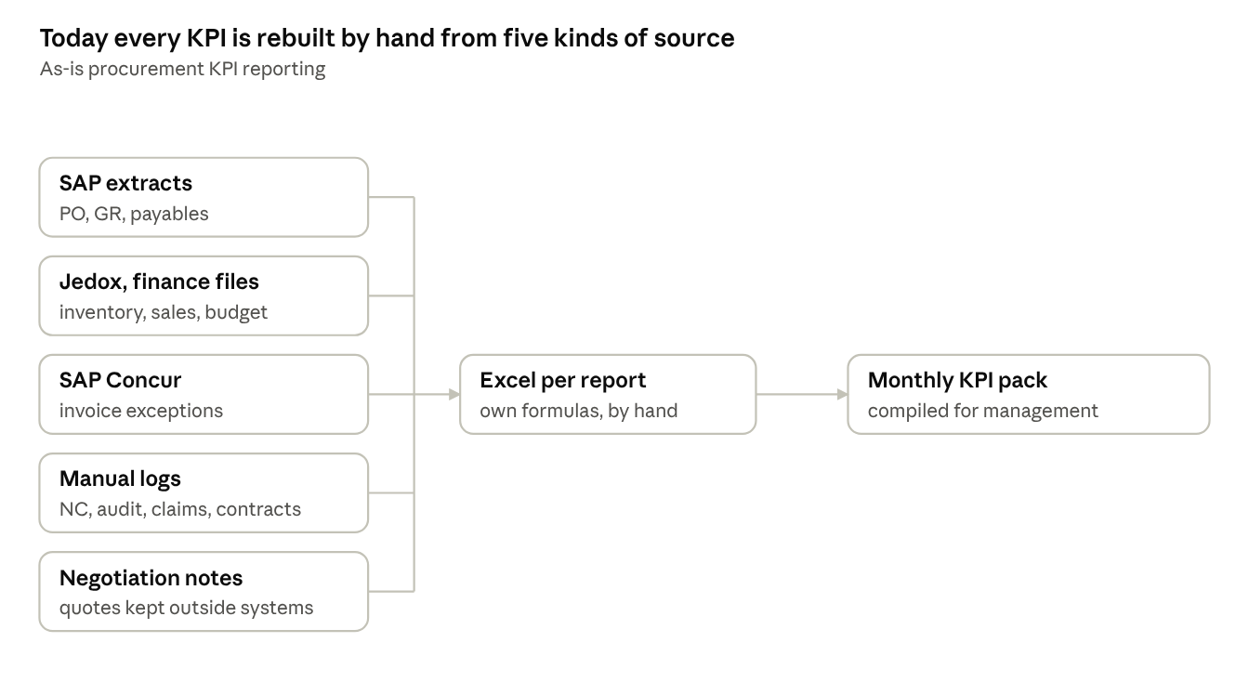
As-is KPI reporting · 5 sources, 1 manual step
Every number in the monthly pack passes through a hand-built Excel file, so none of it can be drilled back to the transaction it came from.

5. Pain areas
Every KPI is rebuilt by hand each month from extracts and logs, so the numbers depend on who compiles them and cannot be drilled into.
# | Pain area | Impact
P1 | Negotiation history (quoted vs final price) not held in any system | Effort savings cannot be audited
P2 | Each report is a separate Excel file with its own formulas | Effort each month; inconsistent figures; key-person dependency
P3 | NC, audit, contract and claims logs are kept manually by different teams | Data gaps; slow responses to management
P4 | Invoice exceptions (no GR, price or quantity mismatch) found only at posting | Late payments; repeated supplier follow-up
P5 | Concur returns posting status but not payment status | Suppliers and procurement cannot see whether an invoice is paid
P6 | Hard-copy invoices still required | Paper handling alongside the digital flow
P7 | Returns not posted against GR | Credit notes cannot be matched to invoices; claims tracked by hand
P8 | DIO and DPO assembled from SAP, Jedox and finance files | A top-management KPI depends on manual steps
P9 | Price changes explained by hand for management | Slow explanations; no market context
P10 | No SSO beyond Microsoft; several separate logins | Access management overhead; weaker control
P11 | Planning system future (Jedox replacement) undecided | Reporting and integration design may change

6. To-be process
In the target design, operational KPIs come straight from platform transactions: savings, NCs, audits, claims, contracts and invoice exceptions. Executive KPIs combine these with SAP and planning data in one analytics layer, with Excel and Power BI export for finance and planning.
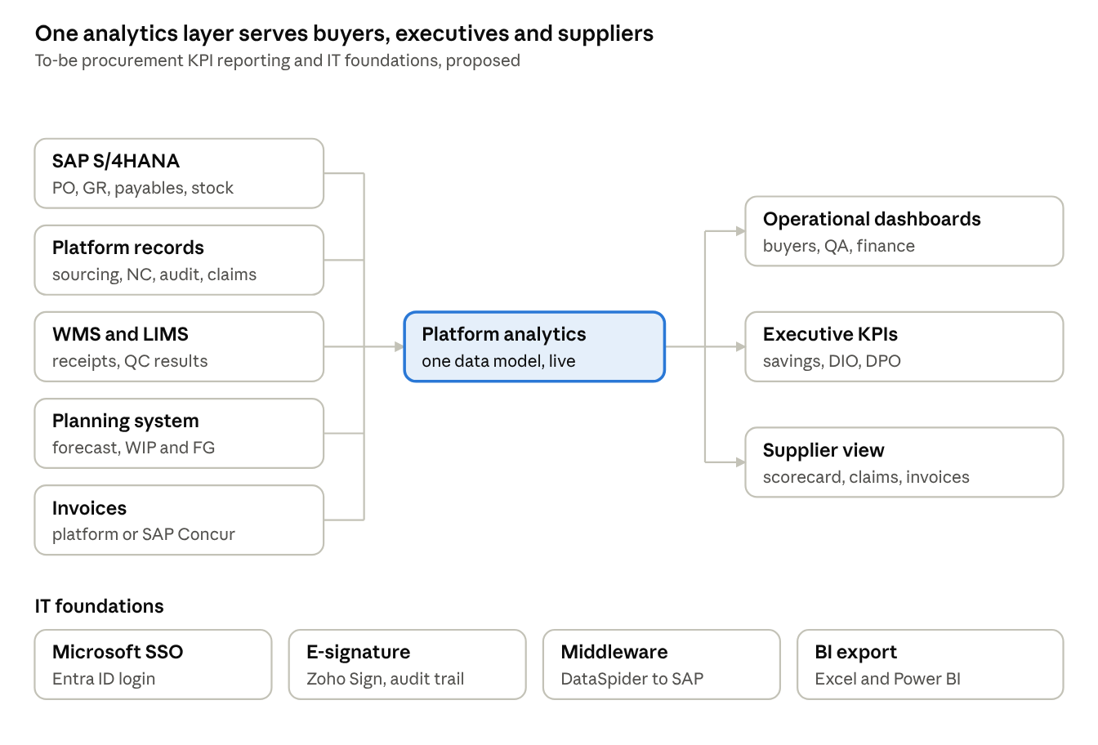
To-be KPI reporting and IT foundations · 5 sources, 3 audiences
What changes:
- Negotiation: quotes and negotiation rounds are captured in sourcing, so effort savings are calculated, not typed.
- NCs and audits: NC, audit and claims dashboards come from the records created in the quality and RTV flows (see 28 Oct documents). The manual logs are retired.
- Invoice status: invoice exceptions and payment status are visible to procurement and suppliers, whether invoicing moves to the platform or stays in SAP Concur.
- DIO and DPO: become dashboards on agreed formulas, fed from SAP and the planning system. They are not rebuilt in Excel.
- Access and signing: users sign in through Microsoft SSO, and contracts, audit summaries and debit notes are signed electronically with an audit trail.

7. Functional requirements
Eighteen requirements came out of Session 4. Priorities are Durvah's proposal for Ajinomoto to confirm.
ID | Area | Requirement | Priority
AR-01 | Savings | Calculate actual savings (budget vs PO price) and effort savings (quoted vs negotiated) per material, month, RM/PM and local/import, with forex conversion | Must
AR-02 | Negotiation record | Capture every quote round and the final negotiated price in sourcing, so effort savings can be audited | Must
AR-03 | Spend analysis | Spend by supplier and material: quantity, total value, average price, vs budget | Must
AR-04 | Pricing database | Price history per material and supplier with reason for change; supports management explanation of increases | Must
AR-05 | Market insights | AI-assisted context on price drivers by material and origin (phase 2) | Could
AR-06 | NC dashboard | NC count by supplier, month, class and category from system NC records; replaces the manual NC log | Must
AR-07 | Audit dashboard | Audits planned, completed and rescheduled with results; open findings and closure status | Must
AR-08 | Audit finding closure | Supplier submits CAR with evidence and implementation date; system reminds the supplier to submit effectiveness evidence about one month later; QA, R&D or procurement auditor approves closure | Must
AR-09 | Critical NC verification | QC receiving and QC production verify deliveries before a critical NC closes (approval step) | Must
AR-10 | Claims tracking | Debit note and claim memo per NC with signed approval (procurement director); supplier credit note uploaded and linked to the invoice; ageing dashboard for finance | Must
AR-11 | Invoice exceptions | Outstanding-invoice dashboard by reason (no GR, price, quantity), ageing and supplier; supplier sees status. If invoicing stays in Concur, Concur and SAP data feed this report | Must
AR-12 | Contracts dashboard | Contracts by status, validity and expiry | Should
AR-13 | Payment terms programme | Current and negotiated payment terms per supplier, with progress tracking | Should
AR-14 | DIO and DPO | Dashboard for RM/PM (and WIP/FG where planning provides it) against target, using SAP and planning data with formulas agreed with finance | Should
AR-15 | Development tracker | Track new material and supplier assessments as projects with stages and dates (phase 2 candidate) | Could
AR-16 | Exports and BI | All reports exportable to Excel; data available to Power BI | Must
IT-01 | Single sign-on | Platform login through APC's Microsoft (Entra ID) SSO; licences assigned per user | Must
IT-02 | E-signature | Integrate Zoho Sign (or native e-signature) for contracts, audit summaries, debit notes and performance reports, with audit trail | Should

8. Open questions
# | Question | For
Q1 | Will invoicing move from SAP Concur to the new platform, or stay in Concur with an integration? Is the hard-copy original still legally required? | Finance
Q2 | What are the exact DIO and DPO formulas, data sources and targets? | Finance (Bryan Roman)
Q3 | Will Jedox be replaced next year, by what and when? Will SAP planning modules be adopted? | IT, planning
Q4 | Can the planning Power BI dashboard and its data be shared? Should Power BI remain the executive reporting layer? | Planning (Rachelle), IT
Q5 | Can Zoho Sign integrate with external platforms (API), and is it licensed for procurement users? | IT, Chris Ballesteros
Q6 | Is SSO via Microsoft Entra ID acceptable for the new platform, including SAP access later? | IT
Q7 | Are the production loss report and the development tracker in phase 1 scope? | Chris Ballesteros
Q8 | What role does DataSpider play in the new integrations, and who supports it? | IT

9. Action items
Eight actions came out of Session 4. Durvah needs the report templates with their formulas (A1) to design the dashboards. Owners are proposed from the discussion; please confirm.
# | Action | Owner | Due | Status
A1 | Share all KPI report templates (savings, NC, audit, contracts, payment terms, price monitoring) with formulas; dummy data is fine | Procurement report owners | This week | Open
A2 | Share the DIO and DPO workbook with formulas and data sources | Finance (Bryan Roman) | This week | Open
A3 | Share the outstanding invoice and outstanding claims monitoring templates | Finance (AP and claims) | This week | Open
A4 | Share the NC log template and the supplier master and pricing database once cleaned up | Procurement / QA | Next week | Open
A5 | Arrange a view of the planning Power BI dashboard | Chris Ballesteros with Rachelle | This week | Open
A6 | Confirm the planning system roadmap (Jedox replacement, SAP planning study) | IT | 30 Oct IT session | Open
A7 | Confirm Zoho Sign integration options and SSO approach | IT | 30 Oct IT session | Open
A8 | Present the proposed architecture and recommendations to APC management and IT | Durvah (Kishore, Sunit) | 30 Oct, 10:00 (tbc) | Open

